PRACTICAL NO. 7

Aim:Implement a typical service and a typical client using WCF

Steps:
At Server Side:
- Open visual studio create new project WCF web application.
- On solution explorer open Iservice1.cs write logic similarly on service1.svc.
- Run service1.svc for testing service.
- Now run Iservice1.cs and click on service1.svc and copy wsdl url.
At Client Side:
- Create a Client Application (ASP.Net Web Application C#)
- In solution explorer ( right click on the project) →Add →Service References →paste the wsdl copied url→Click on Go → now select your Service and method(here we have used Addition method).
- Now again right click on project → add→new item→Web Form
- After creation of Web Form →go to design →add 2 Textbox,Button and a Label(for output).
- Now run the client Service.
Server Side:
- Service1.cs
using System;
using System.Collections.Generic;
using System.Linq;
using System.Runtime.Serialization;
using System.ServiceModel;
using System.ServiceModel.Web;
using System.Text;
namespace WcfService1
{
// NOTE: You can use the "Rename" command on the "Refactor" menu to change the interface name "IService1" in both code and config file together.
[ServiceContract]
public interface IService1
{
[OperationContract]
int Addition(int a, int b);
}
}

- Service1.svc.cs
using System;
using System.Collections.Generic;
using System.Linq;
using System.Runtime.Serialization;
using System.ServiceModel;
using System.ServiceModel.Web;
using System.Text;
namespace WcfService1
{
// NOTE: You can use the "Rename" command on the "Refactor" menu to change the class name "Service1" in code, svc and config file together.
// NOTE: In order to launch WCF Test Client for testing this service, please select Service1.svc or Service1.svc.cs at the Solution Explorer and start debugging.
public class Service1 : IService1
{
public int Addition(int a, int b)
{
return (a + b);
}
}
}
Output:
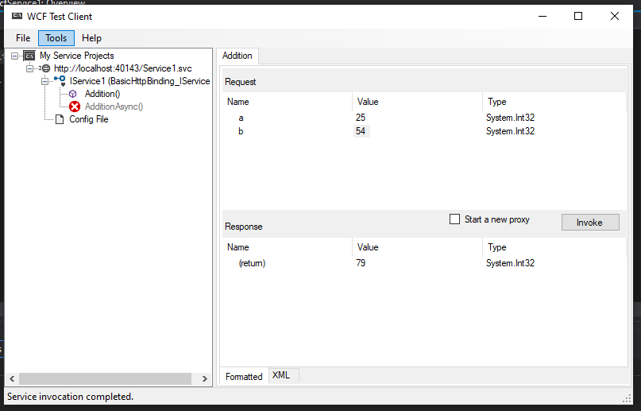

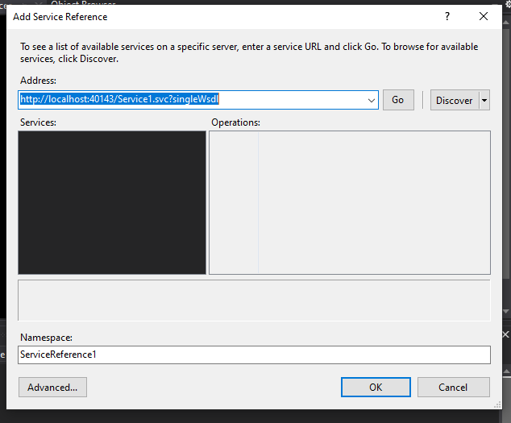

Client Side

using System;
using System.Collections.Generic;
using System.Linq;
using System.Web;
using System.Web.UI;
using System.Web.UI.WebControls;
namespace clientt1
{
public partial class WebForm1 : System.Web.UI.Page
{
protected void Page_Load(object sender, EventArgs e)
{
}
protected void Button1_Click(object sender, EventArgs e)

{
int num1 = System.Convert.ToInt32(TextBox1.Text);
int num2 = System.Convert.ToInt32(TextBox2.Text);
ServiceReference1.Service1Client service1 = new ServiceReference1.Service1Client();
Label1.Text =service1.Addition(num1,num2).ToString();
}
}
}
Output:
